

FORM 3 : FY 2026/27
CLOTHING TEXTILE FOOTWEAR AND LEATHER GROWTH PROGRAMME

Company Name:

Trading Name:

Financial Year End

Date of First Funding Approval:

Complete the questionnaire in soft copy (word version or electronic format) and email the completed form to the relevant email address provided. In addition, please print the completed form and attach the documents as required in the documentation checklist when submitting your application.
The electronic version should also assist your business when or should you apply again for under the CTFLGP.
Thank you.

CTFLGP APPLICATION – FORM 3
The purpose of the Form 3 is to assist the applicant in preparing a comprehensive and structured business plan. The guidelines included throughout this form are intended to help the applicant address all information required by the CTFLGP desk to adequately assess and understand the application. Applicants are required to complete the business plan directly within this form, ensuring that all sections are addressed in full and in accordance with the provided guidance.

A business plan is a working document that reflects the business strategy of a company, its operating structure, and most importantly, its financial plan. It needs to show the company’s strategy going forward, to ensure sustainability and growth of the business. The document should be maintained by all businesses and updated continuously to reflect any changes which may potentially affect the business. A business plan should also be drafted for a start-up business and then updated when necessary hereafter. When submitting a business plan to a financier as part of the funding application process (either for an existing or start-up business), the business plan should provide sufficient information to convince a financier or potential investor of the prospective success of the business venture.
It is crucial that the foundations of the business plan be based predominantly on verifiable facts and market research including changes in market forces affecting the business, key risks and mitigating factors, as opposed to opinion and belief. The more facts in the business plan, the easier it is for a potential financier to decide on whether to invest in a business. The business plan should demonstrate that the business venture is commercially viable and that all those involved in the project, from management to employees and consultants, have the skills, knowledge and/or qualifications, to deliver on the plan.

- PURPOSE OF FUNDING

How much do you need for Capex and for what.
How much do you need for Working Capital and for What.
Name of Consultant used and amount payable – please submit the consultancy agreement if applicable.

- BACKROUND
  - General overview of the business:
  - State if the business is a start-up operation or an existing business;
  - Background/history of the business including the geographic location of the operations and how long the business has been operating for;
  - Industry within which the business operates;
  - Products/services being offered;
  - Outline of expansion plan/start-up plans and the amount of funding required;
  - Other material issues such as number of existing and new jobs to be created; and
  - New/existing contracts or letters of intent secured.
  - Products including HS codes.
  - Shareholders of the company (percentage, race, age, and gender)
  - Group structure (if there is more than one within the applicant company).
  - BBBEE level

- MANAGEMENT

  - Profiles of the executive Management of the company, including their education and experience, in particular, roles for Finance, Operations and Marketing functions.
  - Amount of funds that shareholders will be injecting into the project as their own contribution and the source of these funds.

Name | Age | Position | Duties & Responsibilities | Qualifications | Experience
 |  | CEO
 |  | Operations
 |  | Marketing
 |  | Finance
 |  | HR

- COMPLIANCE

• Tax Clearance
Provide SARS document

• Bargaining Council Compliance Certificate
Provide certificate

• FICA
Provide FICA documents as per checklist

• Environmental Requirements
Environmental certificate from the municipality where applicable, where there is discharge of effluent from the production process

- WORKFORCE PROFILE

Number of employees in the company and their categories. Should be provided on Form 2 (Sheet 1).

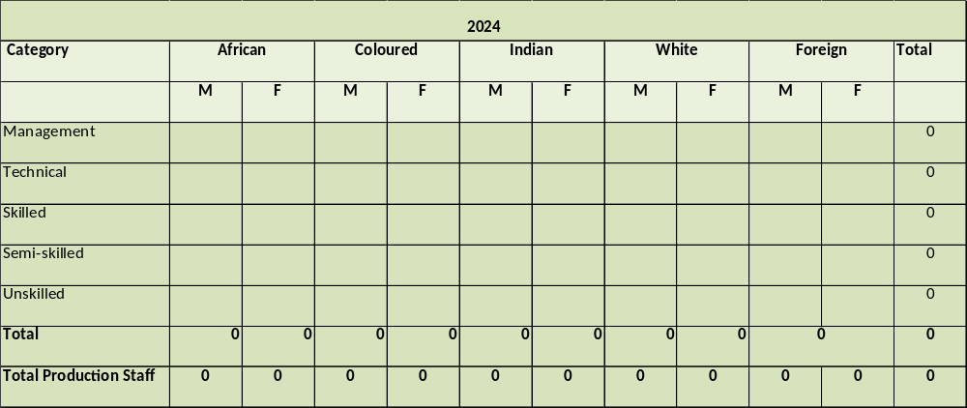

- MARKETING CONSIDERATIONS

- Details of Customers and where sales growth emanates.
  - List the key clients of the company, are they chain stores or independents
    - In support of the above, please provide copies of all contracts with customers, letters of intent from potential customers (detailing volumes, prices and duration) and/or verifiable market research to be provided.
- What are some of your marketing initiatives
- Sales budget (Projected turnover levels need to be based on secured contracts, letters of intent and/or verifiable market research).
  - Revenue Breakdown per major client (reflecting Volumes and rates) or
  - Breakdown per product (reflecting Volumes and rates) or

  - Breakdown per department (reflecting Volumes and rates).
Please ensure that 2 of the above revenue breakdowns have been provided.
  - Raw material Breakdown by product
- Competitor analysis (e.g. pricing, product or service portfolio, key target market and locations etc.);
  - Competitive edge of the business;
- Demand vs. supply;
- Future developments (technological, new market entrants, alternate products etc.); or other networks and relationships created;
- Selling strategy used (e.g. discounts offered, rebates etc.)
- Do you currently export your products or plan to in future.

- TECHNICAL CONSIDERATIONS
Please provide details regarding the below:
- Quotations from suppliers for all fixed assets to be purchased, time required for delivery after order placement, delivery and installation costs (not older than three months).
  - Terms and conditions of payment for machinery to be purchased (deposits, progress payments etc.).
  - Ensure that the fixed assets to be purchased are sufficient to meet production forecasts from a capacity (i.e. units produced per hour/day/week/month) and electricity consumption point of view.
  - Be sure to budget adequately for other ‘soft assets’ such as office furniture, photocopy and fax machines as well as other equipment that are necessary but not directly related to the production process.
  - Copies of all warranties and guarantees, repairs and maintenance agreements relating to the assets to be acquired.
  - The design, size, technology type, and layout of the plant and equipment.
  - Production process description and process flow diagram or images.
  - A copy of the factory/building layout.
  - Identification of key suppliers and quotations for all raw material input costs (not older than three months).
  - Details of any registered processes (patents, trademarks etc.) and terms of using the process or license if applicable.
  - Provide details of the building lease agreement, duration, rental amount and size of the building.

  - Details regarding any capacity constraints and how this can be resolved.
  - A list of Raw material suppliers and their location (local or overseas).
  - Cost-to-company breakdown of all salaried, waged, part-time and contract employees, historical and going forward. Indicate labour hours and number of shifts per day.
  - Number of staff and their salaries/wages, pensions, allowances, bonuses, commissions and other benefits by job title or rank.
  - Ensure that staff numbers are adequate and in line with production capacity and forecasts including labour hours and number of shifts

- ADDITIONALITY CONSIDERATIONS
Complete the Form 2 (CTFL Summary sheet) to provide additionality from this funding. This includes localisation, production units, employment and exports. Complete for those applicable.

- FINANCIAL VIABILITY
  - Five-year financial projections (Income statement, balance sheet and Cashflow) in Excel
  - Please include a forecast year (Management Account date to financial year end) in addition to the 5 year projections.
    - Include sales budget, raw material budget and salaries and wages budget.
    - Raw material to be accurately costed and budgeted for per product item.
    - Sales projections should tie in closely with any contracts and letters of intent obtained from potential customers and marketing research performed. Sales should be conservatively phased into expected levels over a reasonable period to allow for the time it will take to penetrate the market.
    - Assumptions used in projections
    - All expenses in the income statement should be adequate for the size of the business and its operations. For example, the salaries and wages bill should be directly linked to the number of staff (including directors) to be hired, multiplied by their total cost-to-company.
  - Latest Management accounts in Excel
  - 2 sets of AFS for the last 2 financial period

    - Please provide breakdown of Cost of sales in addition to the AFS. The breakdown should clearly reflect the raw materials utilized in the sale of the products reported in Revenue.
    - Where applicable, provide copies of agreements with other financiers for existing loans.
    - Details of overdraft and other debt facilities in place.
    - Fixed Asset register
    - Debtors, creditors terms.
    - Inventory days for raw materials, WIP and finished goods days as per AFS, Management accounts and projections
  - Purpose of funding required.
  - Payment schedule for the loans to related parties and terms (loan agreement).
  - Reason for paying dividends where applicable, dividend policy.

- ALIGNMENT TO MASTERPLAN
As part of your business plan which of the Masterplan objectives are you aligned with, i.e.
  - Increase revenue of locally manufactured goods.
  - Grow manufacturing output per employee.
  - Deliver upstream manufacturing employment growth.
  - Enhance the value chain’s cost, process and product competitiveness.
  - Improve financial returns.
Choose 1 or 2 applicable from the above list and expand in detail.

- DEVELOPMENTAL RETURNS
What is your BBBEE Level, do you employ women, youth or people with disabilities. How many jobs will be created by this funding. Do you have any developmental initiatives in your community or your plans.

- PREVIOUS PIP
Total amount received from PIP if any.
How funds were utilised.
Impact of PIP to business and performance.

- PREVIOUS CTFLGP APPLICATION
Total amount received from PIP if any.
How funds were utilised.
Impact of CTFLGP to business, performance and agreed upon milestones.

- CONTACT DETAILS
Full Names and ID numbers of all shareholders, cell numbers, email and their addresses.
- If company, Full name, Reg no, company address and contact person, (including his/her Cell numbers, email and physical address).
- If Trust, Full name and Trust number, Trust address, contact person, (including his/her Cell numbers, email and physical address.

- ASSET SUMMARY
Complete Form 2 (Asset Summary) if your buying machinery with the funding. This should be a list of machinery intended to support the additionality on the CTFL summary sheet
NB: Provide 3 quotes for each asset.

- WORKING CAPITAL SUMMARY
Complete Form 2 (working capital summary). These should be working capital to support the additionality on the CTFL summary sheet.

